CEN 4010 (Summer 2020): Principles of Software Engineering

Milestone 4: Beta Launch and Final Project Reviews

Project Title: “OwlTalk”

Group Number: 4; Team Name: “Cheesy“

Group Members:

* Anthony Pancione (Scrum Master) – apancione2018@fau.edu
* Jonah Livingston (Back-End Lead) - livingstonj2015@fau.edu
* Nicholas Child (Product Owner) - nchild2019@fau.edu
* Tyler Do (Front-End Lead) - tdo2018@fau.edu

Due Date: July 28, 2020

Revision Table:

|  |  |
| --- | --- |
| Date: | Revision: |
| 6/15/2020 | Added Revision Table, Executive Summary, Competitive Analysis, Data Definitions, Overview & Scenarios, High Level functions, Non-Functional requirements, High Level System Architecture, Team Roles, added documentation onto GitHub |
| 7/10/2020 | Added High Level UML Diagrams, High-level System Architecture, and Key Risks sections alongside a link to our vertical prototype DB search demonstration and website. The website’s basic functionality also has been implemented |
| 7/24/2020 | Added descriptions for Title page, Product Summary, Usability Test Plan, QA Test Plan, Code Review, Security, and Adherence to original non-functional specs. Post Creation features have also been implemented onto the site |

YouTube Demo: <https://youtu.be/b_Al9rViyR4>

Product Summary

Product Title: “OwlTalk”

Create Account: ​

Users can create an account by entering their email, desired username, and password. After their account has been created successfully, the user will be able to access the site’s greater features.

Signing into Existing Account:

Once an account has been created users will be able to sign in whenever visiting the site. To sign into an existing account the user will enter the same username and password they used to create their account.

Browse/Post Discussion Blocks:

Once the user is properly signed in, they will be directed to the home page where they can view posts and discussions created by other users that they themselves can also contribute to. Naturally, they can create original posts of their own too.

Unique Feature(s): ​

Our project is unique because socialization at FAU has been almost entirely erased since quarantine began. College is a critical time to socialize and create new connections. We believe there is no available platform where FAU students can freely socialize in an unmoderated environment. It will be a site of the students, by the students and for the students. The setup will be a Reddit style posting board where verified users can make new posts and like/comment on old posts.

Product Link: <https://lamp.cse.fau.edu/~cen4010s2020_g04/Milestone2/Cheese/index.php>

Usability Test Plan

Test Plan Goals and Objectives:

The tests are planned to be performed on the OwlTalk website itself to ensure that the live system can execute all of the envisioned features properly, and to ensure that the posts uploaded onto the website will be visible to all users that are signed in, and stored on the database. We are also performing these tests to make sure that all of the basic functions required for use across the site are easy enough for the average user to understand, and do not require any kind of intimidating skill set beyond that of your standard Internet user.

After the completion of these tests, we hope to better understand the performance quality of our system and learn if there are any errors in need of being corrected.

System Setup:

The system setup will be oriented towards PC’s with Internet Browsers.

Starting Point:

The starting point for this test will be our site’s home page. To log in we will use a pre-registered account set up specifically for this test. Once we are logged in, we can confirm if the option to create a post is viewable and functioning on the live site.

Intended Users:

The intended userbase for our site will consist of FAU students who seek further communication with their student body without requiring any in-person interactions. The site will be designed in such a way that any average user will be able to easily understand how the site operates and learn to utilize its features effectively.

Tasks:

* Confirm if users are able to create posts that are viewable to all users on the live site
* Confirm if it is possible to reply and comment to existing posts

Completion Criteria:

We’ll know if the site is in a more completed state if users can properly create accounts on our database and use them to log in properly. They should then be able to view all the existing discussion blocks that have been created up until the point of their login, and also have the ability to either reply to existing posts or create posts of their own.

URL of the system to be tested:

<https://lamp.cse.fau.edu/~cen4010s2020_g04/Milestone2/Cheese/login.php>

Questionnaire Form:

|  |  |  |  |  |
| --- | --- | --- | --- | --- |
|  |  | Disagree | Neutral | Agree |
|  | Questions: |  |  |  |
| #1 | When logged in, is the option to create a post available to the user? |  |  |  |
| #2 | Is the created post visible to its creator and other users alike with the proper content included? |  |  |  |
| #3 | Can people reply to the post? |  |  |  |

QA Test Plan

QA Test Objectives:

The objective of our quality assurance tests is to confirm that our product is meeting all the envisioned goals we sought out to create, or at least to confirm that these goals are on the proper path of continued development. It is important that we test each feature in numerous ways to ensure that no unforeseen errors that could cause problems for the site appear in any circumstance, and if they do, come up with solutions for correcting them. It is hoped that errors are found during this QA testing so that the later testing can be a success without any problems.

QA Hardware/Software Setup:

The hardware setup will be oriented towards regular PC’s. The setup for the software will contain the Internet browsers the site will be running on.

Features to be Tested:

● Creating a new account

● Attempting to create a new account when the attempted username already exists within the website’s database

● Logging in as a valid user and being allowed onto the site

● Attempting to log in as a user that does not exist and being rejected access onto the site

● User made posts will display their creator’s username and date of the post’s creation

● Block posts will be sorted by date (meaning the most recent posts will appear at the top of the discussion forum).

● New post replies are added to the bottom of their respective blocks

● Logging out will return the user to the initial login page

Actual Test Cases:

|  |  |
| --- | --- |
| Test #1: Name | Post Information |
| Description | When a post is created that post should include the creator’s username and time the post was made |
| Input | Create Post Attempt |
| Expected Output | Both the post creator’s name and date/time of posting will be displayed alongside the rest of the post |
| Actual Output (Browser: Firefox) | PASS! The poster’s username is displayed, as well as how many days ago the post was created! |
| Actual Output (Browser: Chrome) | PASS! The poster’s username is displayed, as well as how many days ago the post was created! |

|  |  |
| --- | --- |
| Test #2; Name | Logging Out |
| Description | When a user is logged in the option to log themselves out should always be available |
| Input | Use of the ‘Logout’ button |
| Expected Output | The user should be returned to the site’s homepage upon logging out |
| Actual Output (Browser: Firefox) | PASS! Clicking the ‘Logout’ button sends the user to a unique logout page instead of just logging them out immediately, but otherwise it works!!! |
| Actual Output (Browser: Chrome) | PASS! Clicking the ‘Logout’ button sends the user to a unique logout page instead of just logging them out immediately, but otherwise it works!!! |

|  |  |
| --- | --- |
| Test #3; Name | Invalid Login |
| Description | When attempting to login, if the input username/password don’t align with anything saved in out database the login should fail |
| Input | Inaccurate username/password |
| Expected Output | Some kind of prompt displaying that the attempted login information is inaccurate |
| Actual Output (Browser: Firefox) | PASS! The system even detects specifically if it is either the username or the password that is incorrect and displays that accordingly |
| Actual Output (Browser: Chrome) | PASS! The system even detects specifically if it is either the username or the password that is incorrect and displays that accordingly |

Code Review

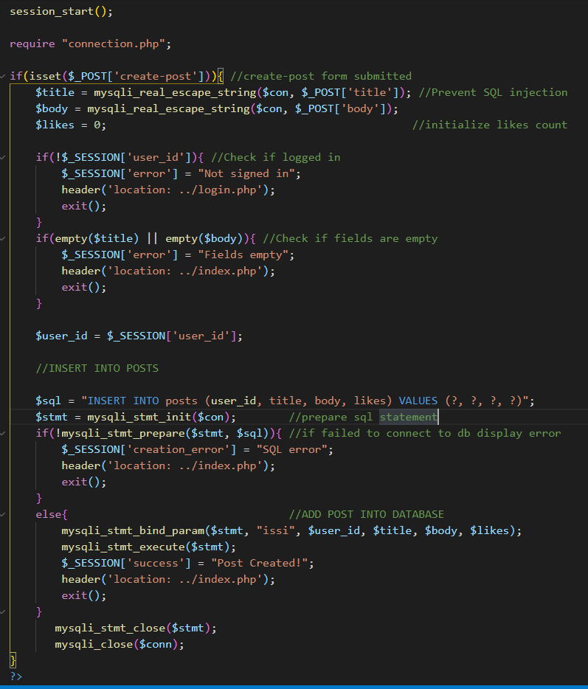The code written for our project is of the object-oriented style. This is because this style naturally lends itself well to the type of data updating our sites features.

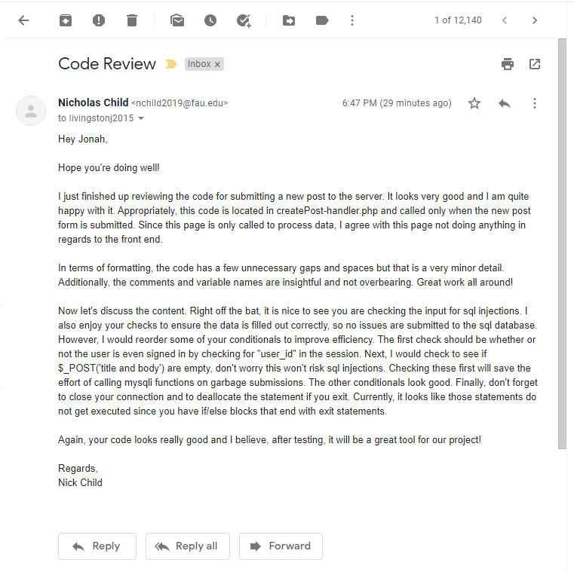

Security

The major assets we seek to project within our site’s database are the credentials our users would decide to use when creating their accounts. The passwords users choose for their accounts are encrypted within our database, and the email addresses that are required for initial registration are not to be displayed publicly and will only be used otherwise for sending important messages pertaining to an update of the site or the user’s account.

When a user attempts to log onto OwlTalk their input is compared with data on the site’s database to make sure the information they are inputting is accurate. If their input doesn’t correspond to anything existing within the database, they will be notified that their attempted username/password is incorrect. The same applies for account registration too. If a user inputs information that is already being used by another user, the page will display a prompt that those credentials have already been used by someone else.

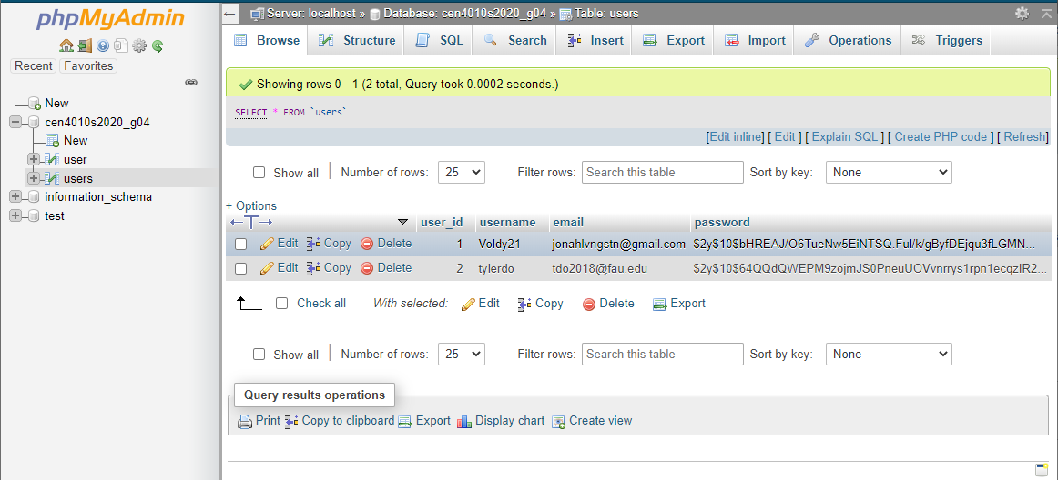

Adherence to original non-functional specs

1. The website should be functional on at least two of the latest versions of major web browsers such as: Mozilla Firefox, Google Chrome, etc. DONE

2. The only language planned for the site to be displayed in is English. DONE

3. Data will be stored in the database on our server. DONE

4. All privacy policies will be communicated to the users upon their registration so that they are aware their privacy shall be protected. ON-TRACK

5. The interface of the site should be intuitive and easy to use by regular people; no prior training should be required to use properly. ON-TRACK

6. Security of the site will require users to register and log in at launch. DONE